PERFORMANCE AND TESTING

Date: 01 NOVEMBER 2025
Team ID:NM2025TMID06078
Maximum Marks: 4 Marks
PROJECT NAME LEASE MANAGEMENT SYSTEM

1.LEASE CREATION
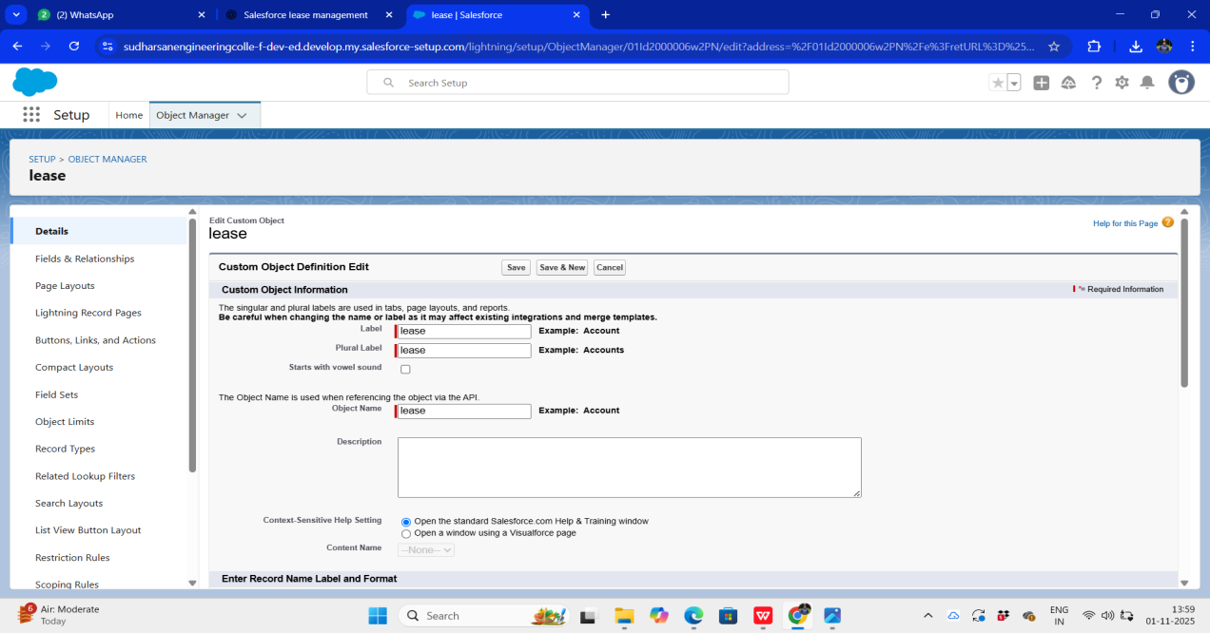

2.DEPARTMENT CREATION

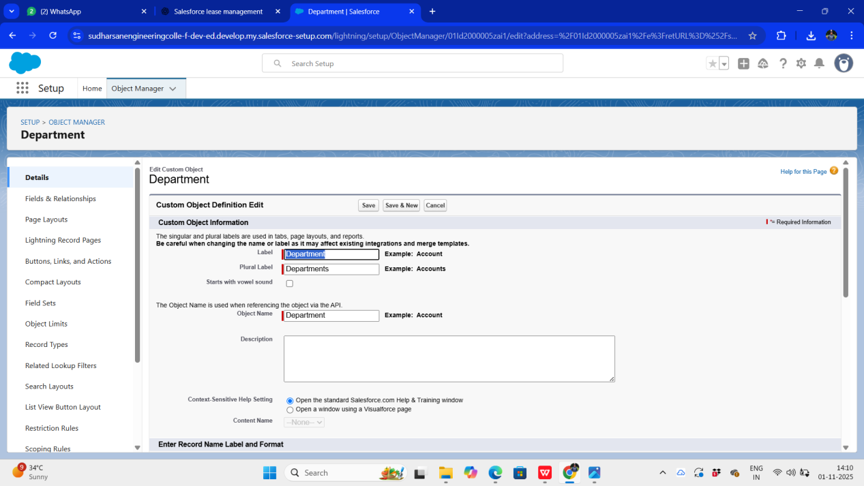

3.TENANT CREATION

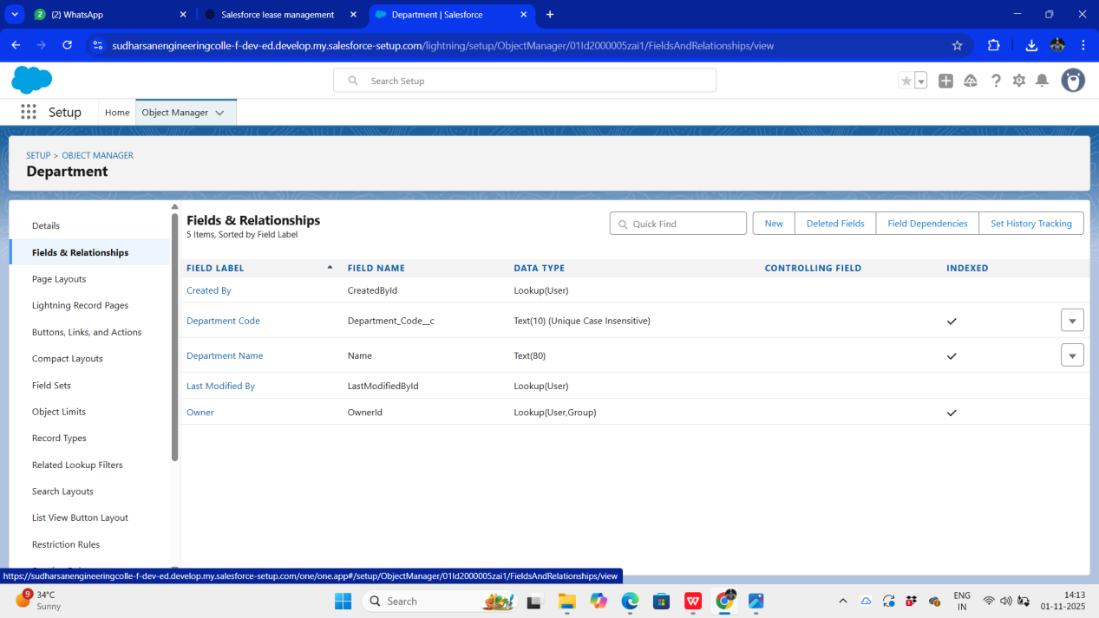

4.PAYMENT FOR TENANT CREATION

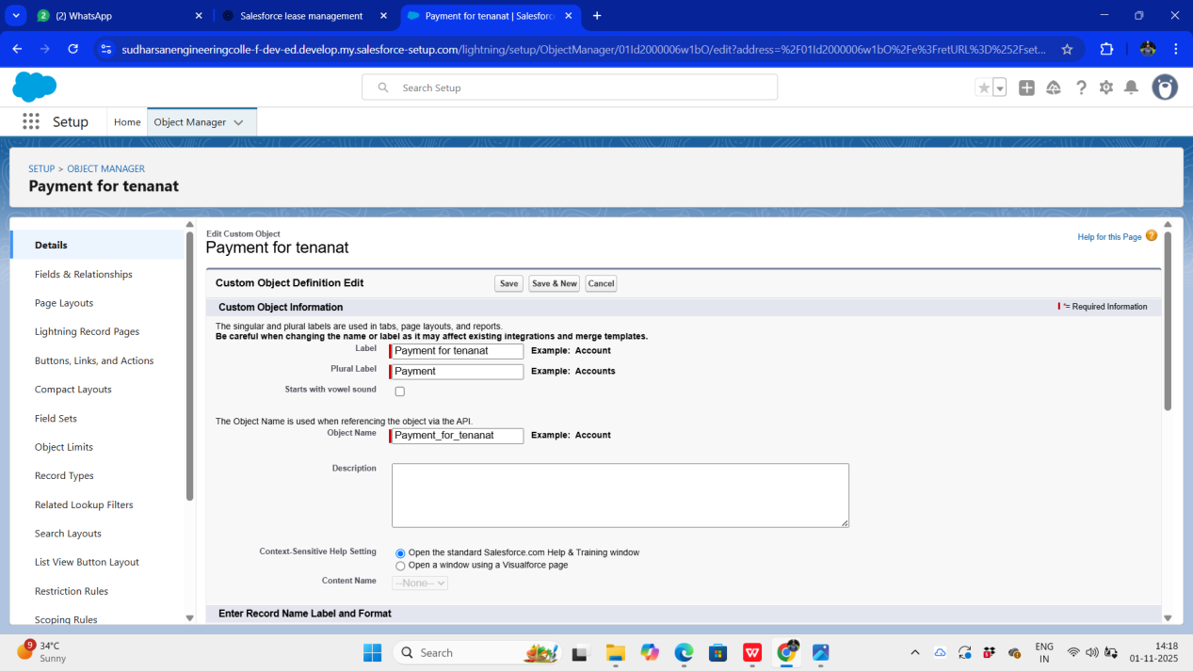

Lease Report Generation
Description:
A custom report was created in Salesforce to analyze lease records based on parameters such as Lease Status, Payment Status, Customer Name, and Expiry Date.The report provides visibility into active and expired leases, helping property managers monitor lease performance and ensure timely renewals or payments.

